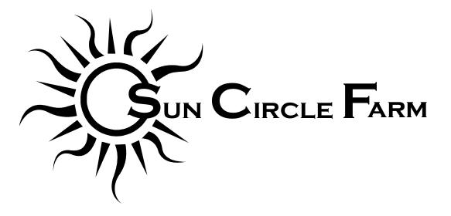
2022 CSA Commitment Form

Shareholder Contact Information
Name: _______________________________________________________
Address: _______________________________________________________
_______________________________________________________
Telephone: _______________________________________________________
E-mail: _______________________________________________________

CSA Share Option
_____ Full Share - $700 ($350 deposit)
_____ Small Share - $450 ($225 deposit)

By signing this form you agree to purchase a CSA share from Sun Circle Farm for the 2022 summer season. Our season will likely run from the week of June 6th or June 13th through the week of October 6th, for a total of 17 weeks. Depending on the season, we might take “off” the first week of July, but will otherwise provide a weekly box of freshly harvested produce certified organically grown on Sun Circle Farm.
The second half of your payment is due by August 1st.
CSA pick-up will be at the farm on Wednesday afternoons.
By filling out this form and purchasing a share you are agreeing that there are no guarantees in agriculture and sharing any potential risks or shortcomings with us.
If you have any questions, please contact me at ancokell@gmail.com, call or text 907-707-3123, or see our website at www.suncirclefarm.com.
Thank you for supporting our farm!

Please make checks payable to Sun Circle Farm and mail them with your completed agreement to:
Sun Circle Farm
5605 Farm Loop Rd.
Palmer, AK 99645

Signature: ____________________________________________________________________

