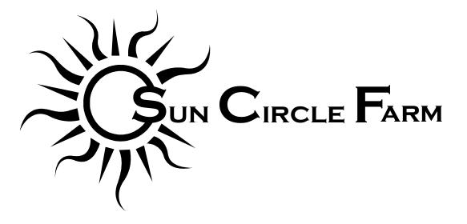
2023 Flower Share Commitment Form

Shareholder Contact Information
Name: _______________________________________________________
Address: _______________________________________________________
_______________________________________________________
Telephone: _______________________________________________________
E-mail: _______________________________________________________

_____ Flower Share - $250

By signing this form you agree to purchase a Flower Share from Sun Circle Farm for the 2023 summer season.

Our season will run a minimum of 10 weeks but we will aim for 12 weeks whenever possible. Start date is highly dependent on weather but is likely to be mid to late June and run through early September.
Flower pick-up will be at the farm on Tuesday afternoons during our Farmstand or on Saturdays at the South Anchorage Farmer’s Market.

By filling out this form and purchasing a share you are agreeing that there are no guarantees in agriculture and sharing any potential risks or shortcomings with us.
If you have any questions, please contact me at ancokell@gmail.com, call or text 907-707-3123, or see our website at www.suncirclefarm.com.
Thank you for supporting our farm!

Please make checks payable to Sun Circle Farm and mail them with your completed agreement to:
Sun Circle Farm
5605 Farm Loop Rd.
Palmer, AK 99645

Signature: ____________________________________________________________________

